

USAGE AND MAINTENANCE MANUAL

ELE

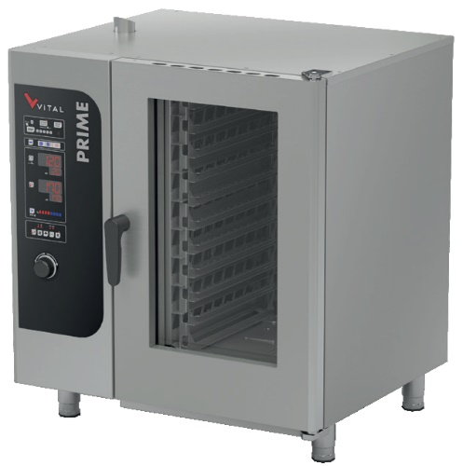**ELECTRIC CONVECTION OVENS**

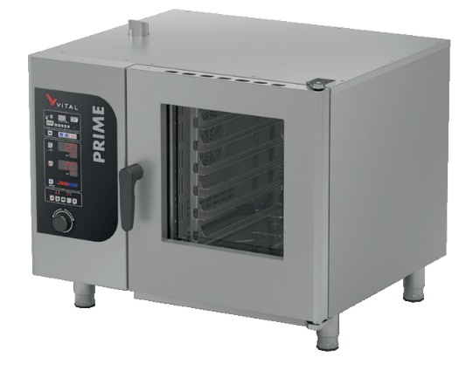

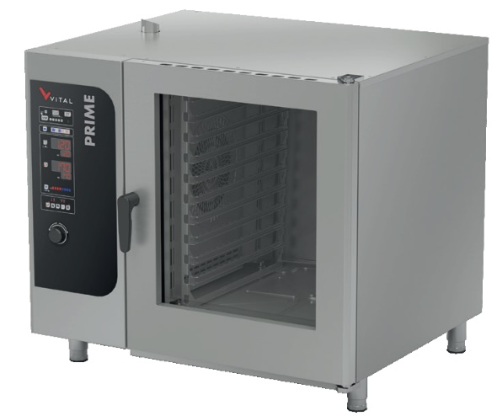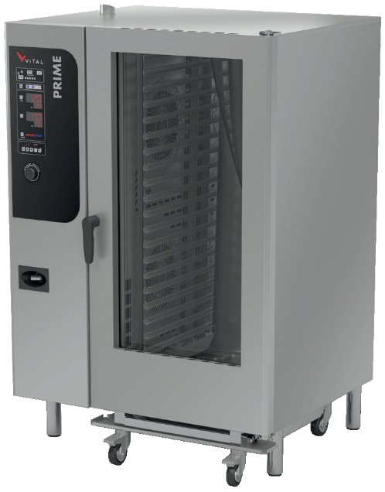

**PRIME102E PRIME202E**

**PRIME061E PRIME101E**

# PRESENTATION

DEAR CUSTOMERS

* To get the best yield of our products that are in compliance with the International Standards, we highly recommend you to read the user’s manual and have it read to your users for long and continuous usages.
* This manual contains important informations about the secure installation, usage and maintenance of the product and necessary remarks to make the most effidicent usage of your device.
* Keep this manual in an easily accessible and safe place to use when necessary.
* Our product is designed for heating and cooking food commodities. Any chemical or liquid substances or similar that can be in contact with the foodstuff, cannot be used for any heat treating that can cause damages for the health.
* The manufacturer cannot be held responsible for any damages from incorrect usage of the device, to people, the environment, or other materials resulting from translation or printing of this booklet.

# INDEX

PRESENTATION 2

INDEX 3

SAFETY DETAILS 4

TECHNICAL SPECIFICATIONS 5

TRANSPORTATION, PLACEMENT AND READY TO INSTALL 7

ELECTRICAL CONNECTION 8

CONTROL PANEL 9

Manual Cooking 10

Program Cooking 12

USAGE 16

Cooking Recipes 16

1-) Switching On 18

2-) Switching Off 18

CLEANING 18

MAINTENANCE AND MALFUNCTION 19

Problems and Solutions 19

WARRANTY CONDITIONS 20

Out of Warranty Cases 21

AUTHORIZED SERVICE START-UP PAGE 23

Start Up Page 23

# SAFETY DETAILS

* Do not expose the device to direct sunlight.
* Any kind of flammable or ignitiable solid or liquid such as alchocol and derivatives, petro-chemical products, wood-plastic materials, curtains, clothes, etc. should not be kept in the area of the device.
* This device must be installed in accordance with the current regulations and should only be used in a well-ventilated area.
* The instructions should be analysed before the installation and the usage of the device.
* The device is designed for professional usage and should only be used by trained personnel.
* It should not be interfered without the presence of the manufacturer or the authorized service.
* The device or its components cannot be used for any other purpose.
* Apart from the heating and the cooking of the food, it cannot be used as a heater for any purpose.
* The device cannot be left uncontrolled as long as it is on.
* Food compatible gloves must be used to protect hands from the overheating.
* In case of fire or flame in the area where the device is, switch off the safety net which is located in the main circuit connection and use the fire extinguisher. Water should absolutely not be used, otherwise the flame will sprawl faster.
* The installation and the maintenance should be carried out by the qualified staff autorized by the manufacturer. Serious danger for the user can be arise due to incorrect installations, maintenances or repairs, and the manufacturer cannot be held responsible.

# TECHNICAL SPECIFICATIONS

(B)

|  |  |  |  |  |  |  |
| --- | --- | --- | --- | --- | --- | --- |
| **PRODUCT CODE** | | | **PRIME061E** | **PRIME101E** | **PRIME102E** | **PRIME202E** |
| **DIMENSIONS**  **(mm)** | **A** | **WIDTH** | 970 | 970 | 1200 | 1200 |
| **B** | **DEPTH** | 880 | 880 | 1060 | 1060 |
| **C** | **HEIGHT** | 850 | 1140 | 1140 | 1830 |
| **TOTAL HEAT CAPACITY (∑QN)** | | | 13 kW | 19 kW | 28 kW | 56 kW |
| **WATER INLET** | | | 3/4” | 3/4” | 3/4” | 3/4” |
| **WATER PRESSURE (Bar)** | | | 1,5-4 | 1,5-4 | 1,5-4 | 1,5-4 |
| **ELECTRICAL INPUT** | | | 380-400 VAC 3N 50 HZ | | | |
| **CABLE SECTION** | | | 5*4 mm2 | 5*4 mm2 | 5*6 mm2 | 5*16 mm2 |
| **MOTOR POWER** | | | 850 W | 850 W | 850 W | 2*850=1700W |
| **WEIGHT** | | | 115 Kg | 130 Kg | 155 Kg | 250 Kg |

A

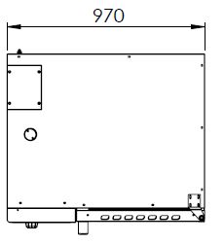

B

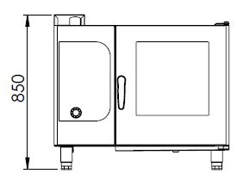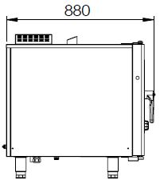

C

PRIME061E

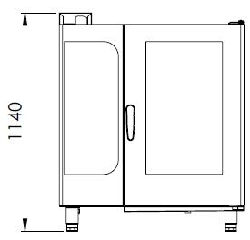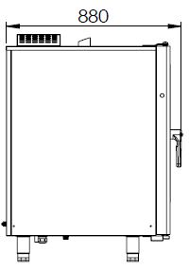

B

A

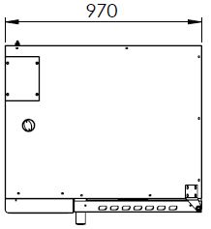

C

PRIME101E

B

A

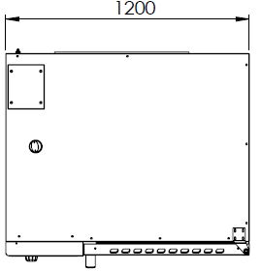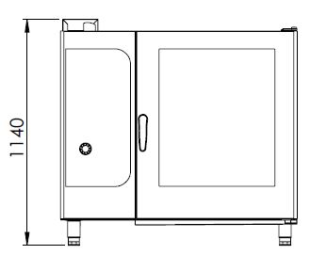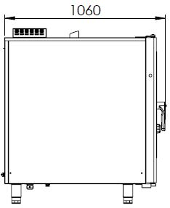

C

PRIME102E

B

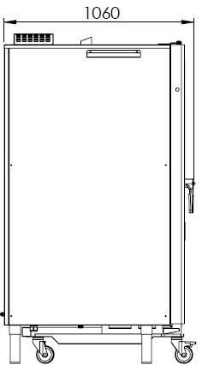

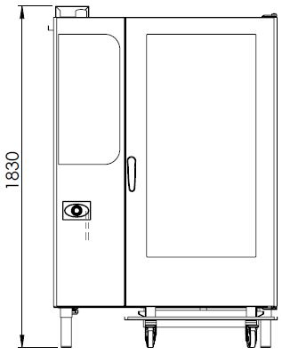

A

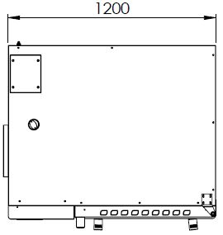

C

PRIME202E

# TRANSPORTATION, PLACEMENT AND READY TO INSTALL

* Do not tilt the device during the transportation, carry it upright.
* Use a suitable vehicle to avoid any kind of damages.
* Do not push or drag the device to bear.
* When transporting by pallet jack or forklift, make sure to not damage the device.
* Carry the device with its packaging until the installation area.
* It should be placed under a ventilation system to avoid any kind of bad smell that may occur during cooking process.
* It is recommended to place a suitable sized hood for the ventilation over the device without blocking the outlet of the chimney.
* In case the device is installed next to a wall, a partition, a kitchen furniture etc., make sure they are made by non flammable material or with a suitable thermal insulation coating with a margin of 10 cm, otherwise with a margin of 30 cm.
* Never place a combustible material on top of the device.
* Make a general cleaning before the first usage. You may use soapy water.
* The operating environment and the ventilation system of the device must be between 10°C to 40°C and have a maximum humidity level of %80.
* The device must be installed in accordance within the instructions.
* The protective film on the surface of the device must be stripped off carefully.
* Convenient electrical connection with the required technical specifications must be installed in the area of the device.

# ELECTRICAL CONNECTION

* Technical specification section should be analysed for the appropriate cable to be used for the electrical connection of the device.
* The electrical supply circuit must be done by the authorized staff. Before installation, make sure that your fitment meets the requirements. The device should absolutely not be used without grounding.
* The electrical voltage must be stable for the proper fonction of the device. If the malfunction is caused by the voltage, the replacement of these parts are considered “out of warranty”. Fault detection is based on the service declaration.
* To prevent the device from any short circuit and overcurrent, the device must be supplied with the appropriate fuse control.

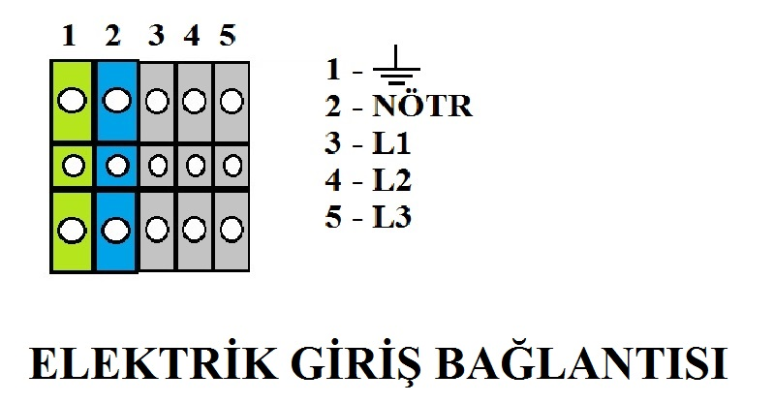

PRIME101E

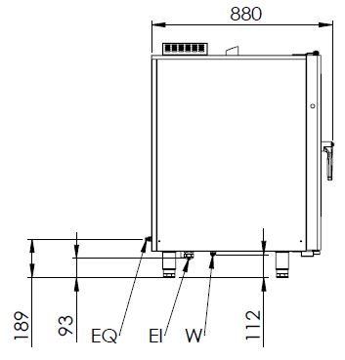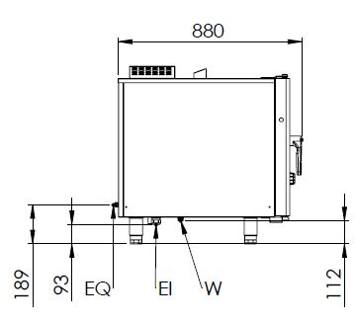

PRIME061E

PRIME202E

PRIME102E

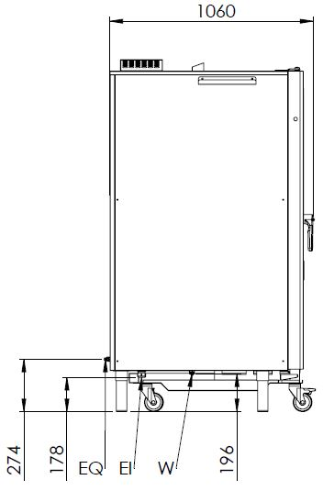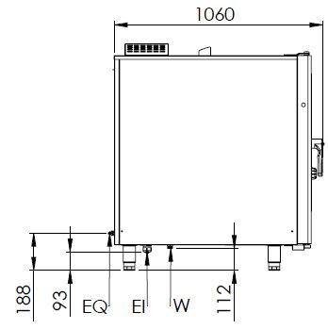

EI=ELECTRICAL INLET

EQ=GROUNDING SCREW

W= WATER INLET

# CONTROL PANEL

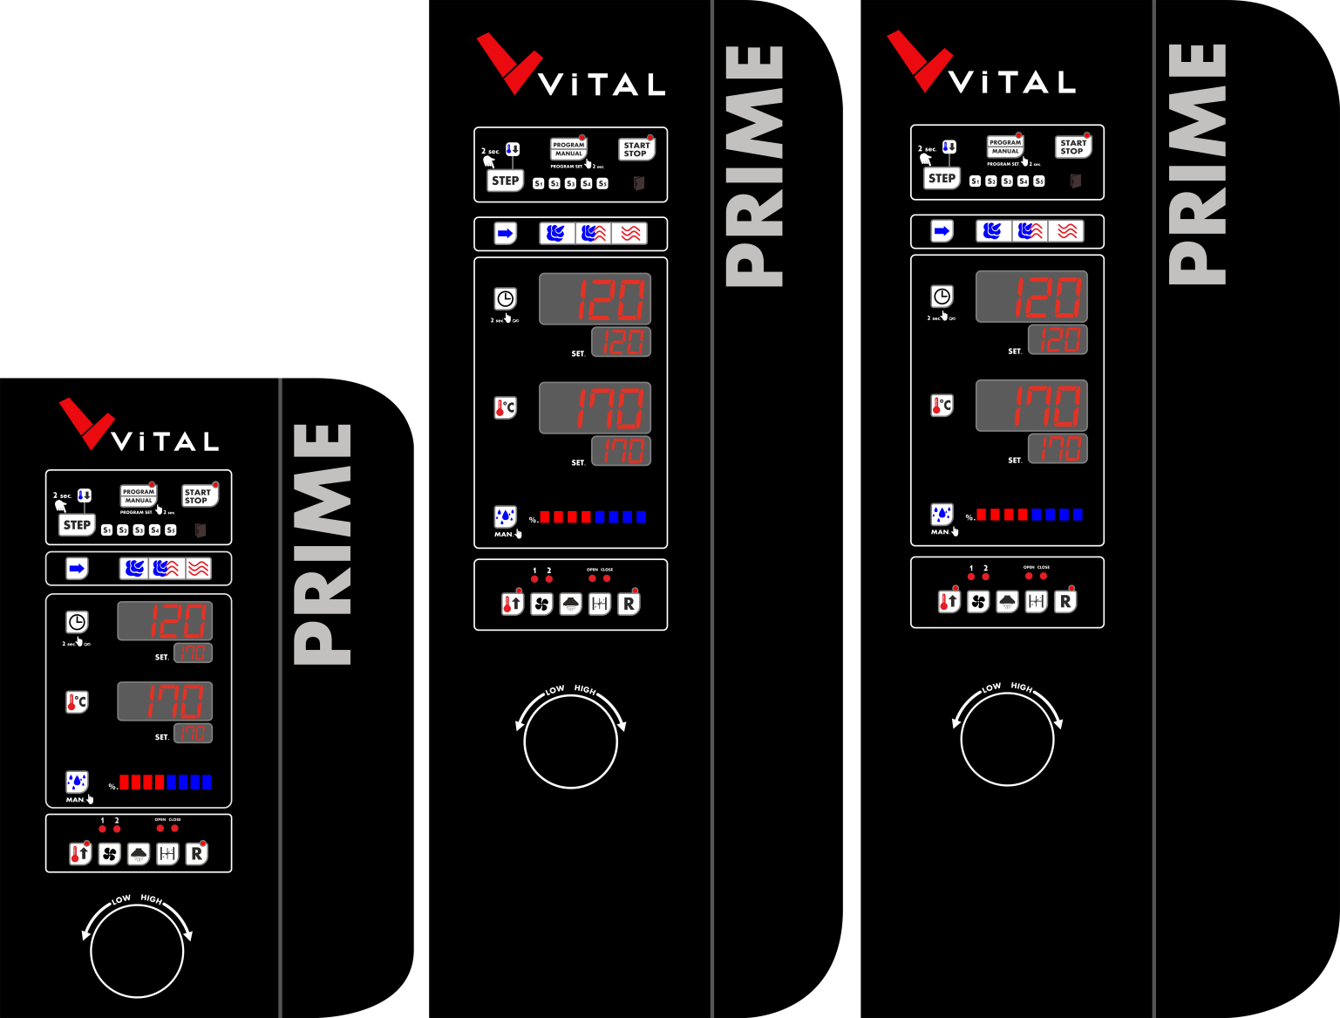

**PRIME061E PRIME101E PRIME102E-PRIME202E**

## C:\Users\ARGE\Desktop\ETİKET GÖRSELLER\PRIME KONTROL PANELİ.png Manual Cooking

**START- STOP BUTTON:** To switch on the oven, press the button once. The light on the button will lit. Pressing a second time on the button will turn off the light and the oven will switch off.

**PROGRAMMING:** Pressing once on the button will get the oven ready to cook with the last chosen program setting. When the program cooking is active, the settings cannot be changed. The program code to be used while cooking is indicated intermittently on the display. “Example: P11, P12 etc”.

Pressing again the button will activate the manual adjustment. When the manual setting is enable, changing the set points will be active. On the manual adjustment option, the selected setting time will appear intermittently on the display with a “EL” sign. To go on the pogram setting-selecting menu, press and hold the button for 2 seconds.

**COOKING STEPS:** You may switch between the cooking steps to set the program. The cooking steps are displayed with the indicators S1-S2-S3-S4-S5.

** FAST COOL DOWN:** The indicator light will flash when fast cooking mode is active.

**DOOR INDICATOR:** The indicator will flash when the door is open.

**COOKING MODES:** Pressing the button will select the cooking methods located on the side. These methods are;

**HUMIDITY MODE: Max temperature: 120 oC**

**CONVECTION HUMIDITY MODE: Max temperature: 250 oC**

**CONVECTION MODE: Max temperature: 285 oC**

**TIMER:** The time set indicator will start flashing when the button is pressed. The required time can be entered with the adjusting knob.

**TEMPERATURE:** The temperature set button will start flashing when the button is pressed. The required temperature can be entered with the adjusting knob.

**HUMIDITY:** In the Humidity mode, 100% humidity will appear on the display with 8 active stages. Pressing the humidity setting button on the Convection+Humidity mode will make the humidity indicator flash. Then, the required value can be entered. Pressing and holding the button will manually humidify the oven.

**PRE-HEATING:** The preheating is activated first by pressing the button before the cooking process to preheat the oven with the selected temperature. If the preheating mode is active, the light on the button will lit.

** FAN SPEED:** You may select the fan speed with the stages lights by pressing the button.

1. First stage: HIGH SPEED
2. Second stage: LOW SPEED

** LIGHTING:** You may control the oven lighting with the button.

** AIR FLAP:** You may control the air flap with the button.

**REGENERATION:** Use the combination knob to select the regeneration process. The regeneration mode will start by pressing the button. The light of the button will lit and “r EG”sign will appear on the time display. When the regeneration mode is activated, select the temperature with the temperature button and the time with the timer button. The regeneration mode will desactivate at the end of the selected time period. You may also end this process by pressing the Start-Stop button or by opening the door of the oven.

When the control panel is enabled, it will be ready for the manual usage. You may understand this by the “EL” sign on the time set display. If the program code is displayed (P1,P2,P3…), pressing the programming button once will make the “EL” sign appear on the time set display.

You may select the cooking methods by pressing the Cooking Mode Button located on the side. The lamp of the selected method will lit.

The time setting indicator will start flashing when pressing the Timer button. Then, the required value can be entered. The value on the display will be confirmed when the required value is reached by pressing the adjustment knob or any slection button. “----“ sign will appear on the display when the button is pressed for 2 seconds. In this case, the oven will function without being dependent on the timer. To exit from that function, you may press the timer for 2 seconds.

The temperature setting indicator will start flashing when pressing the temperature button. Then, the required value can be entered. The value on the display will be confirmed when the required temperature is reached by pressing the adjustment knob or any other selection button.

In the Humidity mode, 100% humidity will appear on the display with 8 active stages, and the humidity cannot be adjusted in this mode. Pressing the humidity setting button on the Convection+Humidity mode will make the humidity indicator flash. Then, the required value can be entered. The value on the display will be confirmed when the required value is reached by pressing the adjustment knob or any selection button. To give humidity manually to the oven, press and hold the button.

Preheating, fan speed and air flap controls can be done optionally.

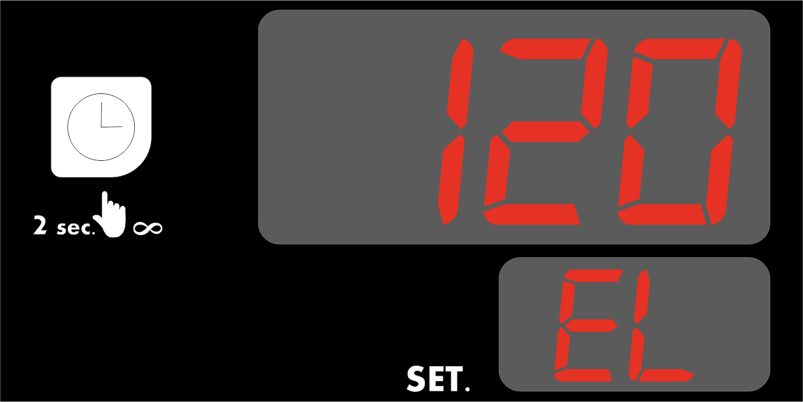

>>>>>

>>>>>

>>>>>

>>>>>

>>>>>

>>>>>

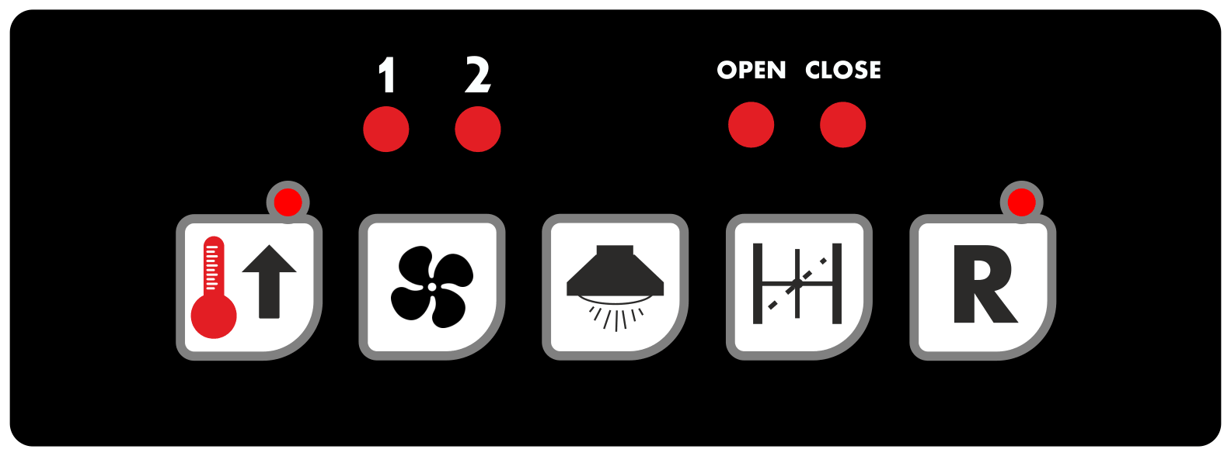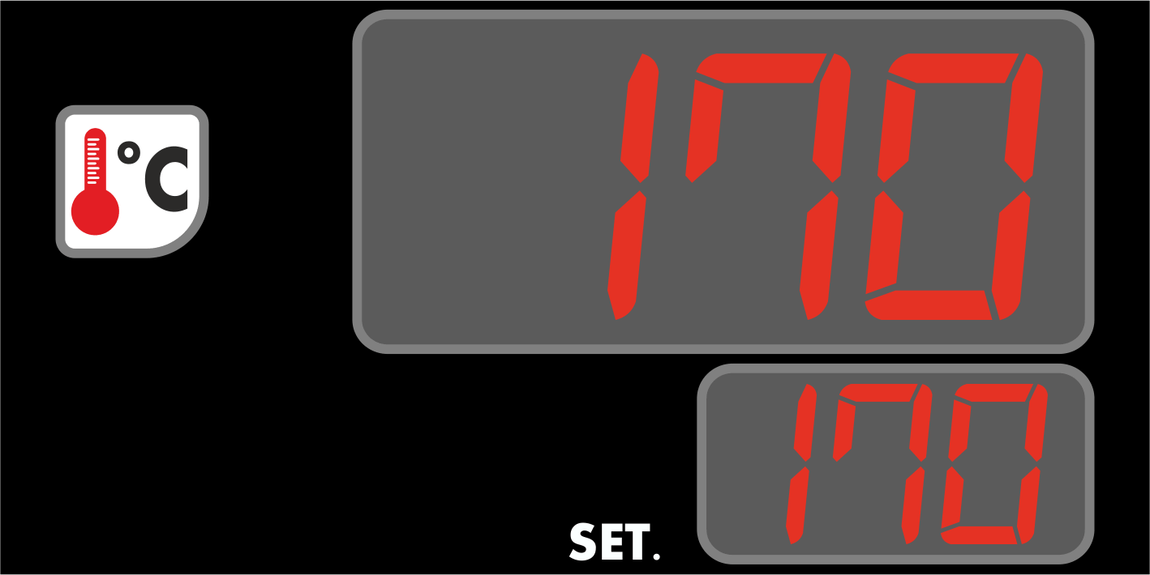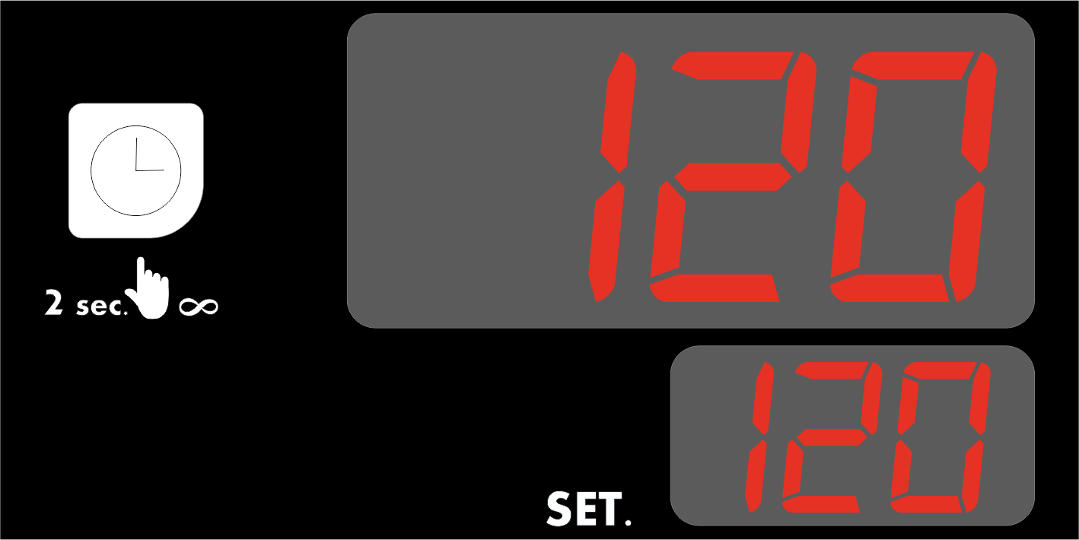

The oven will switch on by pressing the START-STOP button once. When the oven is switched on, the red lamp on the button will lit. Pressing again on the button will turn off the light and the oven switch off.

## C:\Users\ARGE\Desktop\ETİKET GÖRSELLER\PRIME PROGRAM EKRAN.pngProgram Cooking

PRIME Convection Oven includes 20 programmable cooking memories and 5 adjustable cooking stages in the pre-set program.

To enter the programming menu, press and hold the programming button for 2 seconds.

You may observe the program stage from the temperature display each time the stage button is pressed (S1, S2, S4, S4, S5). To change the stages order or to observe the values, you may press the button to skip when programming.

When being on the program menu, the program code will appear on the temperature display. The program selection is made each thime the programming button is pressed. This may be observed by the program code changes on the temperature display (P1, P2, P3,P4,…)

The selection can be done from the display located on the side by pressing the cooking mode button on the relevant program and step.

 The timer setting indicator will start flashing when pressing the Timer button. Then, the required value can be entered. The value on the display will be confirmed when the required value is reached by pressing the adjustment knob or any selection button.

When the display is adjusted to “000”, the oven will not operate in the adjusted set but in the previously selected set. This may be observed by the display lamps. The stage indicator lamps will indicate in which stage the program is.

The temperature setting indicator will start flashing when pressing the temperature button. Then, the required value can be entered. The value on the display will be confirmed when the required temperature is reached by pressing the adjustment knob or any other selection button

 In the humidity mode, 100% humidity will appear on the display with 8 active stages, and the humidity cannot be adjusted in this mode. Pressing the Humidity+Convection mode will make the humidity indicator flash. Then, the required value can be entered. The value on the display will be confirmed when the required value is reached by pressing the adjusting button or any other slection button.

The oven will switch on by pressing the START-STOP button once. When the oven is switched on, the red lamp on the button will lit. Pressing again on the button will turn off the light and the oven switch off.

>>>>>

>>>>>

>>>>>

>>>>>>

>>>>>>

>>>>>>

>>>>>>

>>>>>>













Press once on the START-STOP button to switch on the oven. In case of choosing the wrong program or wanting to abandon the selected program, pressing again within 3 seconds the STAR-STOP button will cancel the program. This will be indicated with a sonant warning on the display with the “----“ sign. When the program starts, the red lamp on the button will lit. Pressing again on the button will turn off the lamp and the will switch off.

**Example**

**Program : 004 Steps : 2 Pre-heating : Active**

**First Step Second Step**

**Time** 10 min 30 min .

**Temperature** 60 oC 190 oC

**Humidity** NO 5th stage

**Fan Speed** Slow Fast

**Air Flap**  ON OFF

**First Step**

|  |  |  |  |  |  |  |  |  |
| --- | --- | --- | --- | --- | --- | --- | --- | --- |
| **F:\LAPTOP YEDEK\MASAÜSTÜ\ETİKET GÖRSELLER\PRİME\PRIME PROGRAM AYAR ADIM 1.jpg** | **ACCESS TO THE PROGRAM AREA**  Press and hold the programming button for 2 seconds to access the display area. This can be observed by the lamp situated on the button. There will also be a sonant warning. The program code will always be displayed as first step, first program. | **F:\LAPTOP YEDEK\MASAÜSTÜ\ETİKET GÖRSELLER\PRİME\PRIME PROGRAM AYAR ADIM 2.jpg** | **SELECTING THE REQUIRED PROGRAM CODE**  The required program code is done by pressing the buttons one by one. This can be observed from the temperature display area. | **F:\LAPTOP YEDEK\MASAÜSTÜ\ETİKET GÖRSELLER\PRİME\PRIME PROGRAM AYAR ADIM 3.jpg** | | | **COOKING MODE SELECTION**  Get to Convection mode by pressing the cooking mode button.  The lamp of the selected mode will lit. Humidity mode or adjustment will not be active in this mode. | |
| **F:\LAPTOP YEDEK\MASAÜSTÜ\ETİKET GÖRSELLER\PRİME\PRIME PROGRAM AYAR ADIM 5.jpg** | **COOKING TIMER**  The timer indicator will start flashing by pressing the timer setting button. The time will be set in step 1 with the adjustment and confirmation buttons. Pressing the button or any other SET button will save the adjusted value. | **F:\LAPTOP YEDEK\MASAÜSTÜ\ETİKET GÖRSELLER\PRİME\PRIME PROGRAM AYAR ADIM 6.jpg** | **COOKING TEMPERATURE**  The temperature indicator will start flashing by pressing the temperature button. The temperature will be set in step 1 with the adjustment and confirmation buttons. Pressing the button or any other SET button will save the adjusted value. | | **F:\LAPTOP YEDEK\MASAÜSTÜ\ETİKET GÖRSELLER\PRİME\PRIME PROGRAM AYAR ADIM 7.jpg** | | | **ENABLING PREHEATING**  Pressing the preheat button will activate the preheating. When this mode is activated, the lamp on the button will lit. The preheating can only be adjusted on the first step. |
| **F:\LAPTOP YEDEK\MASAÜSTÜ\ETİKET GÖRSELLER\PRİME\PRIME PROGRAM AYAR ADIM 8.jpg** | **FAN SPEED**  Press the fan speed button to select the speed. You may observe the speed with the lights on the first and second lamps.  **1- Slow**  2- Fast | **F:\LAPTOP YEDEK\MASAÜSTÜ\ETİKET GÖRSELLER\PRİME\PRIME PROGRAM AYAR ADIM 9.jpg** | **AIR FLOP**  Air flap status is changed by pressing the air flap button. This may be observed by the OPEN-CLOSE button’s lamps. | | |  | |  |

**Second Step**

|  |  |  |  |  |  |  |  |
| --- | --- | --- | --- | --- | --- | --- | --- |
| **F:\LAPTOP YEDEK\MASAÜSTÜ\ETİKET GÖRSELLER\PRİME\PRIME PROGRAM AYAR ADIM 10.jpg** | **COOKING STEP**  You may pass to the next step by pressing the step button. This can be observed from the display area. | **F:\LAPTOP YEDEK\MASAÜSTÜ\ETİKET GÖRSELLER\PRİME\PRIME PROGRAM AYAR ADIM 11.jpg** | **COOKING MODE**  To pass to the CONVEC+HUMID mode, press the cooking mode button. The lamp will lit behind the selected mode. | **F:\LAPTOP YEDEK\MASAÜSTÜ\ETİKET GÖRSELLER\PRİME\PRIME PROGRAM AYAR ADIM 12.jpg** | | | **TIMER**  Pressing the timer button will flash the time SET indicator. Required time can be adjusted with the adjusting and confirmation buttons. You may save the set value by pressing the button or any other SET button. |
| **F:\LAPTOP YEDEK\MASAÜSTÜ\ETİKET GÖRSELLER\PRİME\PRIME PROGRAM AYAR ADIM 13.jpg** | **TEMPERATURE**  The temperature indicator will start flashing by pressing the temperature button. The temperature will be set in step 2 with the adjustment and confirmation button. Pressing the button or any other SET button will save the adjusted value. | **F:\LAPTOP YEDEK\MASAÜSTÜ\ETİKET GÖRSELLER\PRİME\PRIME PROGRAM AYAR ADIM 14.jpg** | **MANUAL HUMIDITY**  Pressing the humidity mode will flash the humidity set indicator. The required humidity level can be adjusted by the adjusting and the confirmation button on the second stage. The indicators behind the lamps will lit. Pressing the button or any other SET button will save the adjusted value. | | **F:\LAPTOP YEDEK\MASAÜSTÜ\ETİKET GÖRSELLER\PRİME\PRIME PROGRAM AYAR ADIM 15.jpg** | | **FAN SPEED**  Press the fan speed button to select the speed. You may observe the speed with the lights on the first and second lamps.  **1- Slow**  2- Fast |
| **F:\LAPTOP YEDEK\MASAÜSTÜ\ETİKET GÖRSELLER\PRİME\PRIME PROGRAM AYAR ADIM 16.jpg** | **AIR FLAP**  Air flap status is changed by pressing the air flap button. This can be observed from the lights on the OPEN and CLOSE buttons. | **F:\LAPTOP YEDEK\MASAÜSTÜ\ETİKET GÖRSELLER\PRİME\PRIME PROGRAM AYAR ADIM 17.jpg** | **CANCELLING THE NEXT STEPS**You may pass to the next step by pressing the Step button. This can be observed from the display area.  Pressing the timer button will flash the time SET indicator. The time “000” on the second step can be adjusted with the adjusting and confirmation buttons. You may save the set value by pressing the button or any other SET button. This will cancel the stages after the second step. | | | This can be observed from the lights of the S1-S2 lamps.  S1, S2, S3, S4, S5 lamps are indicating the stages. The lighted lamps show in which stage is the cooking process. | |

 Press once on the START-STOP button to switch on the oven. In case of choosing the wrong program or wanting to abandon the selected program, pressing again within 3 seconds the STAR-STOP button will cancel the program. This will be indicated with a sonant warning on the display with the “----“ sign. When the program starts, the red lamp on the button will lit. Pressing again on the button will turn off the light and the oven switch off.

If you do not want to start the oven after selecting the program, press and hold the programming button to exit the menu.

# Usage

* The device is designed for professional usage and should only be used by trained personnel.

## Cooking Recipes

The cooking times given are only for illustrative purpose. The actual cooking time depends on the weight and thickness of the food.

**Vegetables**

|  |  |  |  |
| --- | --- | --- | --- |
| **Food Product** | **Temp.**  **(oC)** | **Humidity**  **(stage)** | **Cooking Time (min)** |
| Artichoke | 100 | 8 | 25-35 |
| Whole cauliflower | 100 | 8 | 20-30 |
| Pieces of cauliflower | 100 | 8 | 15-20 |
| Green beas | 100 | 8 | 20-30 |
| Broccoli | 100 | 8 | 15-25 |
| Vegetable soupe | 100 | 8 | 45-50 |
| Cutted fennel | 100 | 8 | 10-20 |
| Carrot | 100 | 8 | 15-20 |
| Stuffed pepper | 185-200 | 7-8 | 15-25 |
| Sliced leek | 100 | 8 | 5-15 |
| Potatos – pared and sliced | 100 | 8 | 25-40 |
| Brussel sprouts | 100 | 8 | 15-20 |
| Green asparagus | 100 | 8 | 10-20 |
| White asparagus | 100 | 8 | 15-25 |
| Stuffed zucchini | 160-180 | 7-8 | 20-35 |
| Green Peas | 100 | 8 | 5-15 |

**Meat**

|  |  |  |  |
| --- | --- | --- | --- |
| **Food Product** | **Temp.**  **(oC)** | **Humidity**  **(stage)** | **Cooking Time (min)** |
| Rib steak (roasted) | 170-185 | 0-3 | 10-25 |
| Tenderloin (roasted) | 180-200 | 7-8 | 35-45 |
| Beef saddle (roasted) | 165-180 | 0-5 | 20-35 |
| Lamb gigot (roasted) | 170-180 | 0-6 | 60-80 |
| Roast beef, grill (cooked) | 115 | 8 | 25-40 |
| 150-160 | 6-7 | 45-50 |
| 220-230 | 0 | 30-40 |

**Poultry**

|  |  |  |  |
| --- | --- | --- | --- |
| **Food Product** | **Temp. (oC)** | **Humidity**  **(stage)** | **Cooking Time (min)** |
| Whole duck | 150-160 | 6-8 | 85-125 |
| 220-225 | 0 | 15-30 |
| Duck breast (fried) | 160-180 | 0 | 5-15 |
| Whole chicken | 165-180 | 6 | 30-45 |
| 185 | 0 | 15-25 |
| Chicken thigh | 180-190 | 7 | 35-45 |
| Turkey breast | 100 | 8 | 10-15 |
| Chicken breast | 100 | 8 | 10-15 |

**Pastry**

|  |  |  |  |
| --- | --- | --- | --- |
| **Food Product** | **Temp.**  **(oC)** | **Humidity**  **(stage)** | **Cooking Time (min)** |
| Apple cake | 160-175 | 0 | 70-80 |
| Bagette (pre-cooked) | 190-200 | 0-7 | 10-20 |
| Cake with biscuits | 190-210 | 0-3 | 8-12 |
| Pastry with millefeuille | 190-210 | 7-8 | 15-20 |
| Flat cake | 160-180 | 0 | 25-40 |
| Cookies | 150-175 | 0 | 10-25 |
| Cake | 160-175 | 0-3 | 50-65 |
| Tulumba | 150-165 | 0 | 35-45 |

**Deserts**

|  |  |  |  |
| --- | --- | --- | --- |
| **Food Product** | **Temp.**  **(oC)** | **Humidity**  **(stage)** | **Cooking Time (min)** |
| Crème Brûlée | 90-100 | 8 | 35-40 |
| Sweet dumplings | 100 | 8 | 20-35 |
| Crème caramel | 90-100 | 8 | 25-30 |
| Compote | 100-125 | 8 | 5-15 |
| Rice puding | 270-275 | 0 | 15-20 |
| Sweet gratin | 180-200 | 0-6 | 20-40 |

## 1-) Switching On

* Turn on the fuse to which the device is connected.
* Open the water inlet faucet.
* Switch on the control panel of the device with the on-off button located on the upper left side of the control panel of the device.
* You may select the fonctions to adjust the requested settings.

## 2-) Switching Off

* After the cooking process, you may switch off your device by pressing on the button located on the upper left side.
* When you are finished with the device, you can turn off the power of the device control panel with the on / off button on the upper left of the device control panel.
* Close the water inlet tap.
* Turn off the power supply fuse for your safety.

# cleanıng

* Disconnect the wiring of the device before starting the cleaning process.
* When cleaning the device, make sure to prevent water from entering the electrical parts.
* Do not wash the device with high pressure water.
* After each usage, clean the device with a cloth dipped in warm soapy water.
* Do not use abrasive detergent or wire brushes when cleaning the device’s surface.
* Clean completely the device on specific periods with convenient cleaning materials.

# MAINTENANCE AND MALFUNCTION

* The maintenance and the malfunction of the device must be carried out by the authorized service or by a personnel assigned by the manufacturer. Otherwise, your device will be out of warranty.

## Problems and Solutions

|  |  |
| --- | --- |
| PROBLEM | SOLUTION |
| There is a warning sign, “E1” is indicated on the display and the device does not function. | Please contact the **AUTHORIZED SERVICE**. |
| There is a warning sign, “E2” is indicated on the display and the device does not function. | Please contact the **AUTHORIZED SERVICE**. |
| There is a warning sign, “E3” is indicated on th display and the device does not function. | Please contact the **AUTHORIZED SERVICE**. |
| The displays of the device do not function. | Check the wiring connected to the device. The connection informations of the device are on the TECHNICAL SPECIFICATION page. If the connections are liable and the displays continue to not function, please contact the **AUTHORIZED SERVICE.** |
| The device does not humidify. | Check the water connection of the device. The connection informations are on the TECHNICAL SPECIFICATION page. If the connection is liable and the humidify continues to not function, please contact the **AUTHORIZED SERVICE**. |

# WARRANTY CONDITIONS

* According to the consumer rights law and commercial law of the Ministry of Industry, except in a special case of agreement, sold industrial products by our company has one (1) year of warranty and that period starts from the delivery date of the product.
* The warranty includes all the components of the device against fabrication or faulty workmanship, eliminations of the problems or malfunctions of the device caused by the workmanship and installation errors, replacement of non-repairable parts or the mending of repaired parts that can be reused. It also includes repairings or changes of the components by the authorized personnel, or the labor fee due to the problem under the warranty.
* In order for the warranty conditions to be valid, the maintenance of the components fixed to the device, the maintenance of the product, as indicated in the user’s manual, should be done yearly and montly and the information form must be held after the maintenance to be presented when required.
* The document of the replacement of the component has to be presented for parts warranty claims.
* In order to continue the warranty period, the paid periodic maintenance has to be done by the authorized service and the information form must be held to be presented when required.
* In case of any malfunctions under the warranty period, the time spent in the repairment of the device is added to the warranty period. The repair can be maximum 30 (thirty) days. This period starts when the device is on the service station. In case of the absence of this station, the period will start when the manufacturer or the importer is notified by the product seller.
* In accordance with the regulations of the warranty document implementation fundamentals published by the Ministry of Industry, the warranty deed of the industrial products are the purchase invoices.
* If there is any kind of malfunctions due to both the materail and the workmanship, or assembly faults under the warranty period, the necessary replacement and reparing will be done by our authorized personnel without any charge.

## Out of Warranty Cases

* If the product is used above its intended purpose, standards or capacity specified by the manufacturer,
* In case of the bad locationing of the product, continuous usage and unhealthy environment (ex: required ventilation), not suitable floor or flat platform, lack of convenient gas pressure,
* If the product hasn’t been used as explained in the instruction manual,
* If the fault is caused by inconvenient, worng or careless usage,
* If the malfunction is caused by fluactions in the mains power, a stoke or a meteor lightening, a fire, a flood, an earthquake or similar cases,
* If the special tools and equipments installed or the maintenance and repair are made by any other person than the authorized person,
* When requesting a service, if the installation-start documents or purchase invoices of the product are not presented,
* If the informations on the documents of the installation, start or maintenance has been destroyed or changed,
* If the paid annual or the contractual periodic maintenance of the product has not been done on time by the authorized personnel,
* If unoriginal spare parts have been used,
* Notifications to our authorized services under the warranty period about the malfunctions that could not have been repaired, will make the time-out of the warranty stop only for that specific malfunction. In this case, the authorized service will inform about the compensation or the non-troubleshooting and the expanded warranty period will end in 3 months in any cases,
* All parts that may be abraded in time such as gaskets, electronic card, doorhandle and mechanism, serigraphy product tag, cables, resistance etc will be replaced in exchange of a fee.
* Damages caused by the unnecessary loss of time, the maleficience, the revenue loss, or the conduction of the product from the defective location to another,
* Malfunctions of the product due to squalidity are not covered by the warranty,
* The methods to be followed about the fault detection and elimination are determied completely by MUTAŞ’s technical service management and the service matter is taken as basis for the determination of the malfunction.
* When the electrical parts of the device are detected by liquid contact, the warranty will not be valid.

# AUTHORIZED SERVICE START-UP PAGE

## Start Up Page

* The model and serial number of your device are shown on the “Technical Data” label affixed to the device.
* Select the technical data according to the device model on the nameplate.

**MUST BE FILLED BY AUTHORIZED SERVICE!**

|  |  |
| --- | --- |
| **COMPANY INFORMATIONS** | : |
| **PRODUCT** | : |
| **MODEL** | : |
| **SERIAL NUMBER** | : |
| **PRODUCTION DATE** | : |
| **SERVICE STAMP AND SIGNATURE** | : |
| **PERSONNEL OF THE SERVICE** | : |
| **CONTACT** |  |
| **TEL** | : **0312 837 76 72** |
| **FAX** | : **0312 837 73 38** |
| **E-MAIL** | : **teknikservis@vitalmutfak.com** |

**CONTACT**



|  |
| --- |
| **MUTAŞ MUTFAK ISITMA SİSTEMLERİ SAN. PAZ. İNŞ. TUR. İÇ VE DIŞ TİC.LTD.ŞTİ**  **HEADQUARTER**  **ADRES: Plevne Cad. No:40 Gülveren / ANKARA**  **TEL: (0312) 363 99 33 FAX: (0312) 363 94 92**  **Web:** **www.vitalmutfak.com** **E-Mail:**[**info@vitalmutfak.com**](mailto:info@vitalmutfak.com) |
| **MUTAŞ MUTFAK ISITMA SİSTEMLERİ SAN. PAZ. İNŞ. TUR. İÇ VE DIŞ TİC.LTD.ŞTİ**  **FACTORY**  **ADRES: Taşpınar Mahallesi Küme Evleri No:154/A Çubuk / ANKARA**  **TEL: (0312) 837 76 72 FAX: (0312) 837 73 38**  **Web:** **www.vitalmutfak.com**  **E-Mail:**[**teknikservis@vitalmutfak.com**](mailto:fabrika@vitalmutfak.com) |

**AFTER SALES SERVICE**

**For the nearest MUTAŞ/VİTAL Athorized Service, please contact the numbers above.**

[**teknikservis@vitalmutfak.com**](mailto:teknikservis@vitalmutfak.com)